UCLA Division of Astronomy & Astrophysics

Astronomy Colloquium

Wednesday, May 6 at 3:30 PM
Room 1-434 PAB

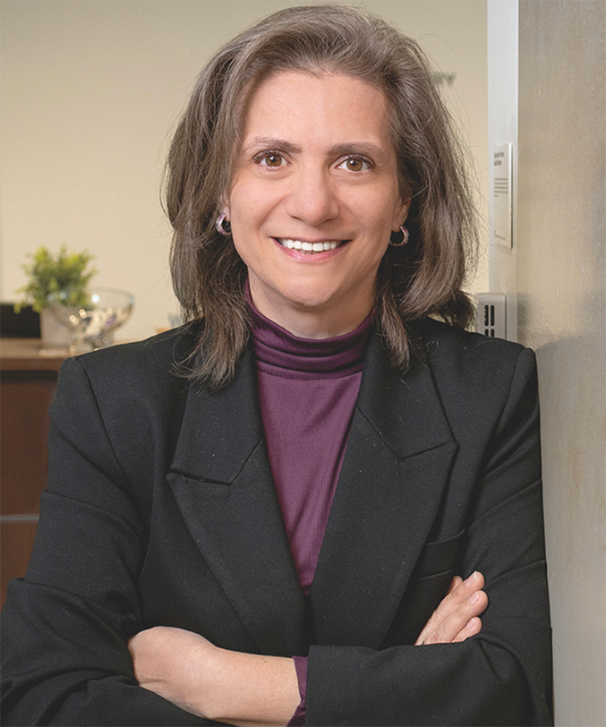

Dr. Vicky Kalogera
Northwestern

The Complexity of Black Hole Masses and Spins

The advent of gravitational-wave astronomy has transformed the study of black holes and their astrophysical properties. With almost 300 black-hole mergers detected by the LIGO-Virgo-KAGRA (LVK) collaborations, we can now probe populations far beyond the reach of electromagnetic observations, uncovering key features in the mass distribution and distinct behavior in spin properties. I will summarize these recent insights, explore connections between masses and spins across multi-messenger observations, and discuss how an emerging formation picture is beginning to take shape.

Hosted by professors: Smadar Naoz, Alice Shapley, Erik Petigura

